Test Plan

# 1 Introduction

## Test Objectives

The purpose of this testing phase of the Mixed reality system should meet the requirements so that:

* The user can move around the stage.
* All music is fully functional and played correctly.
* Animations are running properly.
* The system is easy to use by the end-user.
* All points of interaction are functional.

## System Overview

The Mixed Reality system is a virtual concert hall which has Hatsune Miku, a virtual singer, on stage and performing songs. Within the concert hall, the user can listen to her music as well as move around and participate as a member of the audience.

# Approach

## Assumptions and Constraints

### 2.1.1 Assumptions

* The build will be ready for testing by April 24th, 2025.

### 2.1.2 Constraints

* 9 weeks might not be enough time to fully test the system and then retest to find new bugs due to the implemented fixes.

## Resources

### 2.2.1 Testing Tools

* Playback/Capture device

### 2.2.2 Test Environment

* Hardware
  + Asus
  + Intel Core i7-7700
  + 16GB RAM DDR3
  + RTX2080 Super
* Network
  + LAN
    - Internet connection required
* Software
  + Mixed Reality Build
  + Firefox
  + MS Windows 10 operating system

# 3 Features to be Tested

## 3.1 System Ease of Use

* Camera Control
* Spatial Audio

## 3.2 System Performance

* Time to load assets
* Average FPS during a song
* Time to move between camera positions

## 3.3 Non-player characters

* Miku’s animations
* NPC movement

# Features Not to be Tested

* Lighting
* Audio Controls

# Testing Procedures

## Evaluation Criteria

|  |  |  |  |
| --- | --- | --- | --- |
| **Feature** | **Definition** | **Testing** | **Success Criteria** |
| Collaborative | Ability to support interactions between multiple users. | Perceived presence | Users feel environment is designed to socialize |
| Usefulness | Ability of the system to fulfil its intended purpose. | Conduct user surveys | Most users agree the application is useful |
| Usability | Level of ease of user navigation and interaction. | Users complete specific tasks | Most users’ complete tasks successfully without help |
| Efficiency | Evaluating system performance such as loading times and responsiveness. | Measure loading time | App loads under 10s |
| Reliability | Ability to repeat an experience within the virtual environment. | Run the application multiple times | 9/10 successful runs without errors |
| Accuracy | Evaluation of how similar it is to the intended experience. | User Survey | Most users  agree that it the application is accurate. |
| Stability | The ability to remain operational and responsive, through different events. | Measure FPS between different actions | Frame rate to maintain with 15% of idle FPS |
| Interactivity | Efficacy of user interaction with the virtual environment. |  |  |
| Robustness | Ability to remain operational through different types of errors during runtime. | Send unexpected inputs. | 9/10 it doesn’t crash |

## 4.2 Experimental Protocol

To ensure that all participants are exposed to the same core features and their feedback can be compared consistently, each test participant will follow a standardized testing protocol.

Participants will interact with the following elements:

* The ‘T’ key – to move around the virtual space
* The mouse – the control the camera view and explore the environment
* The play button – To begin the concert performance

Ater interacting with the virtual application, participants will be asked to complete a short survey about their experience to provide insightful information on the functionality of the application features.

Each participant will complete one or more of the test cases below, depending on which aspects are being evaluated.

### Test 1: **Overall User Experience Evaluation**

* Number of Participants: 4
* Background: Average university students
* Experience Level: Mixed
* Features Tested: Usability, Usefulness, Interactivity, Collaborative perception
* Test Method:
  + The users enter the virtual concert and are allowed to freely explore and experience the concert
  + They attend a performance and are told to imagine it as a public event
  + After the session, users complete a survey and answer:
    - How immersive or realistic did it feel (scale of 1-10)?
    - Did it feel like a shared or social environment?
    - Would you use this app instead of attending a real concert?
  + We recorded ease of navigation, interaction attempts, and moments of confusion
* Observations:
  + 3 out of 4 users explored the venue without asking for help
  + All participants were able to begin the concert.
  + 2 users rated the immersion as 6/10 or above
  + One user commented on a lack of social interactive elements
* Conclusion:
  + All users found the experience enjoyable
  + Feedback suggests the experience would feel more social with more interactive crowd.
  + The design supports usability and interaction but collaborative features are underdeveloped

### Test 2: Performance and Functionality Test

* Number of Participants: 4
* Background: Technically proficient students
* Experience Level: Mixed
* Features Tested: Efficiency, Stability, Reliability, Robustness
* Test Method:
  + Users are asked to start up the application and the time taken to load is recorded.
  + Users are then asked to move to different locations and look around the venue while we observe for lag.
  + The framerate is recorded.
  + Light errors such as pressing random keys and rapid teleportation are executed
* Observations:
  + Average total loading time: 12.3s.
    - Average startup time:4.2s
    - Average loading time for venue: 5.29s
    - Average loading time for Artist: 6.0s
    - Average start time for artist animation: 6.38s
    - Average loading time for stage: 12.30s
  + On startup, the application lags when attempting to look around using the camera
  + No lag is noticed when key smashing and during rapid teleportation
  + No crashes during extended usage
* Conclusion:
  + The application is stable and performs efficiently across typical and edge case situations
  + The performance was mostly consistent with slight lag when looking around
  + The robustness of the application was confirmed as no test actions caused it to crash or behave unpredictably

### Test 3: Navigation and Interaction trial.

* Number of Participants: 4
* Background: New VR user
* Experience Level: Beginner or no experience with VR
* Features Tested: Usability, Accuracy, Interactivity
* Test Method:
  + Users enter the virtual concert with no instructions
  + Users are prompted to explore the space and begin the concert all on their own
  + Users are observed for the difficulty level in figuring out and interacting with the elements
* Observations:
  + Two users found the camera controls unintuitive at first but claimed to get used to it
  + Three users commented on the lack of control on the teleportation location
* Conclusion:
  + Most users successfully navigated and interacted with the space after a brief adjustment period
  + The teleportation system requires clearer target locations
  + Overall, the application was approachable for first time users

# Risks and Contingencies

This part of the document describes contingency plans, if the project experiences problems.

* Loading assets (or time) – Risk level moderate to high. Should a problem occur, code should be reviewed and number of assets used should be adjusted. Could have a large effect on user experience.
* Spatial Audio – Risk level low. Should a problem occur, push mono audio untill the problem can be fixed. Could impact user experience.
* NPCs movement – Risk level moderate to high. Should a problem occur, user experience could be affected. Fixing the issue could consume a large amount of time.

# Conclusion

The application met most of its intended goals. Users found the experience immersive, functional, and mostly easy to navigate. There were minor usability issues such as teleportation targeting and camera handling which were identified but did not significantly affect the user engagement.

Key areas for improvement in the application include clearer teleportation logic and an increased social presence in the crowd reactions and interactions

# Appendix:

**SURVEY QUESTIONS**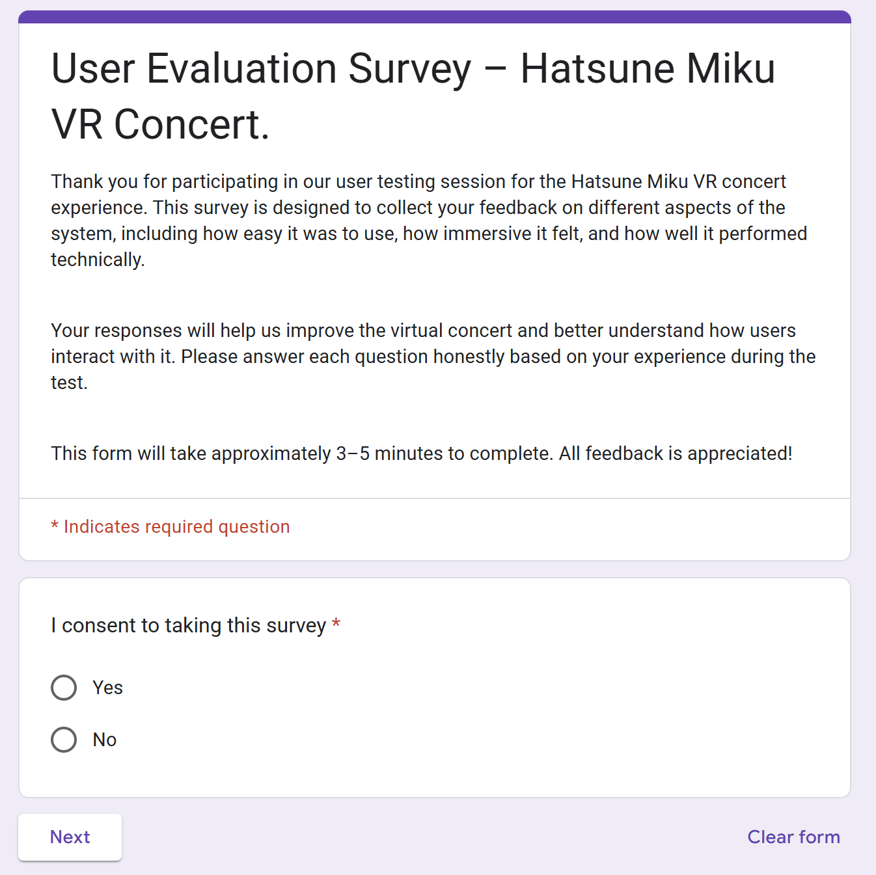

Figure 1.1

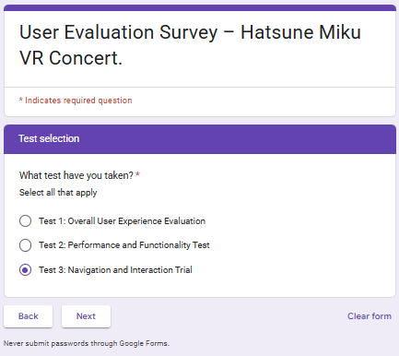

Figure 1.2

Figure 1.3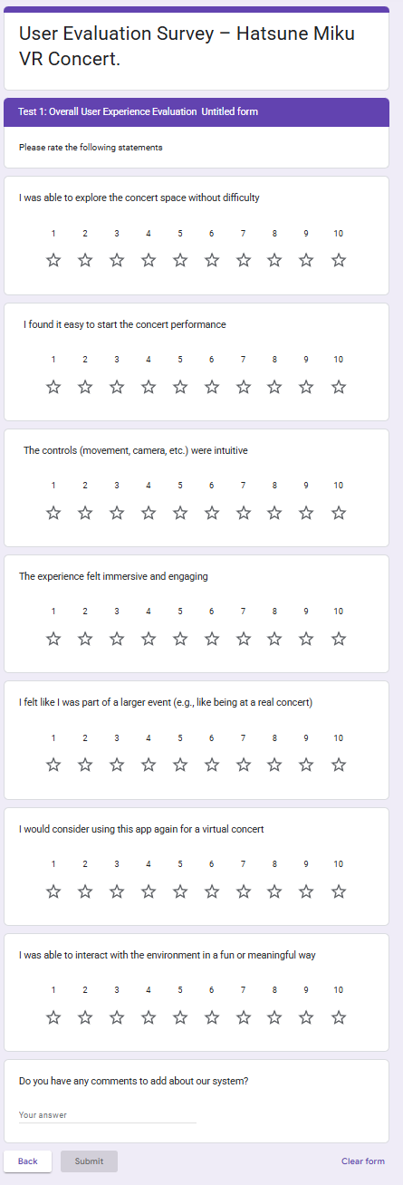

Figure 1.4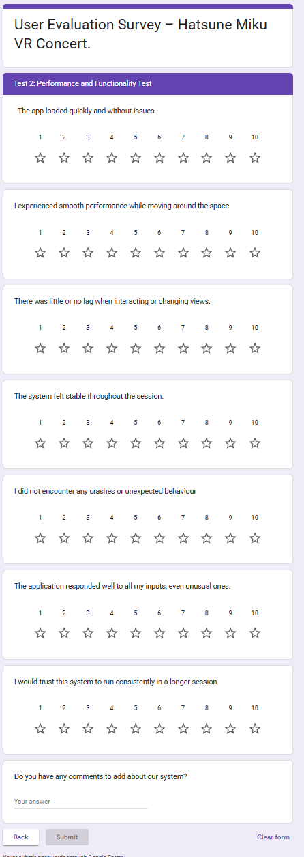

Figure 1.5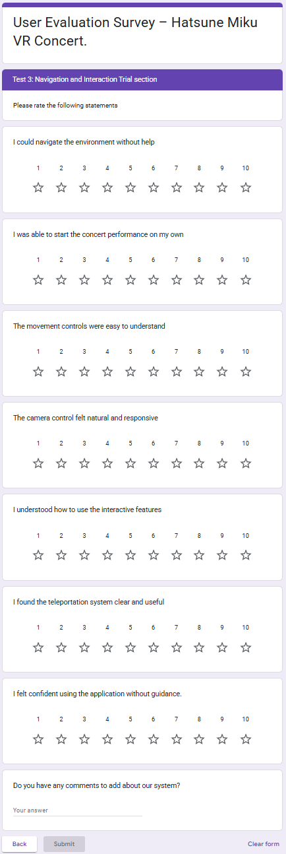

**SURVEY RESULTS**

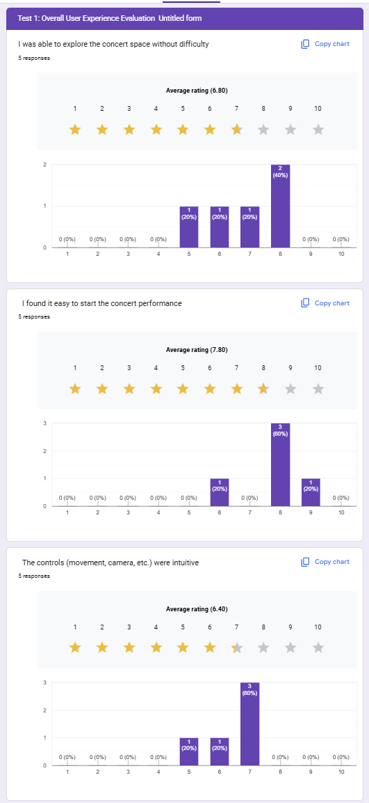Test 1

Figure 2

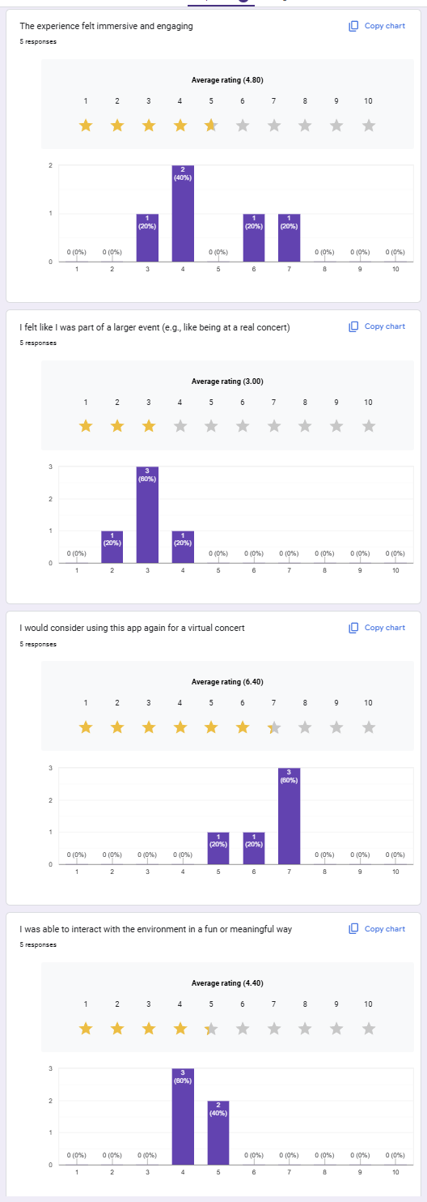

Figure 2.2

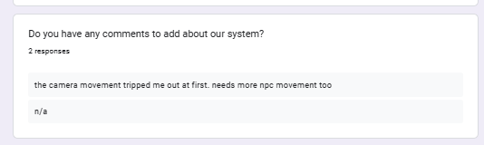

Figure 2.3

Test 2:

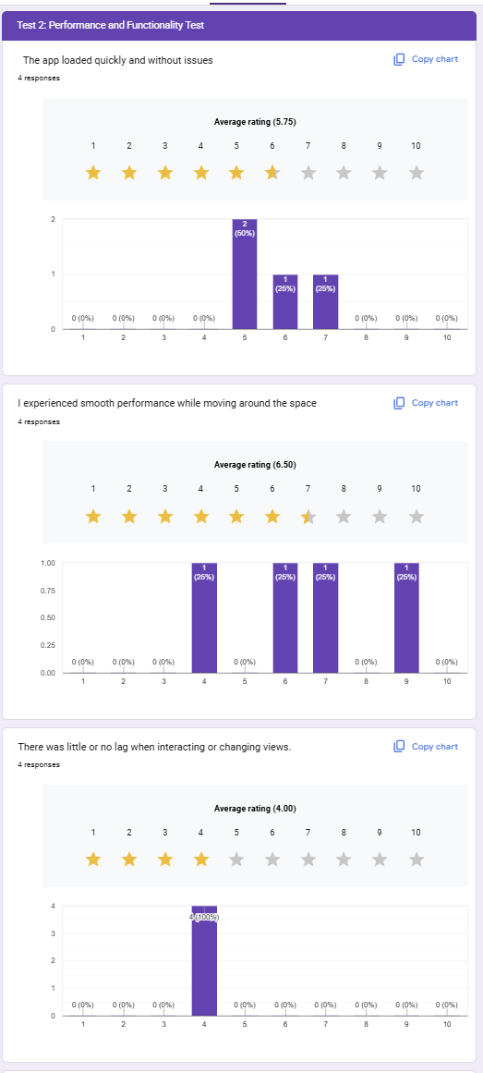

Figure 3.1

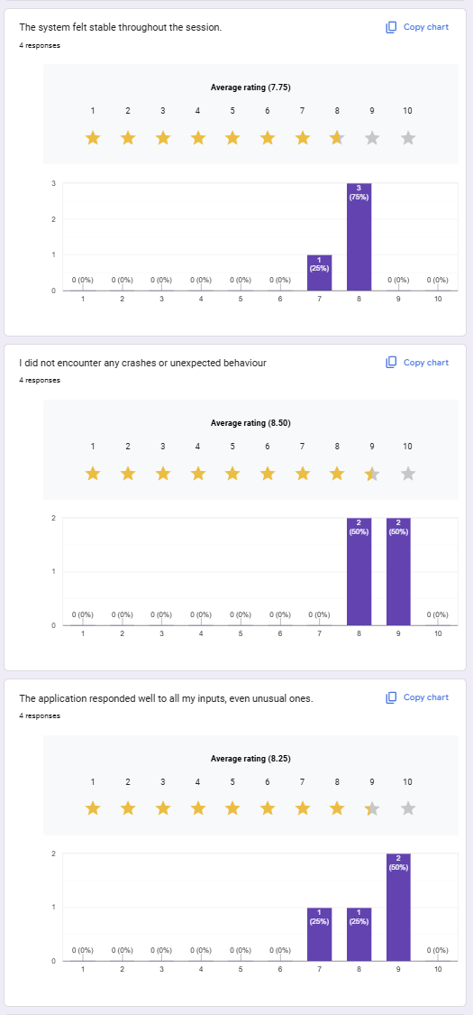  
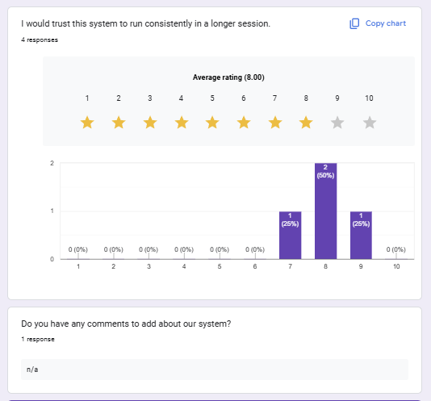

Figure 3.2

Figure 3.4

Test 3:

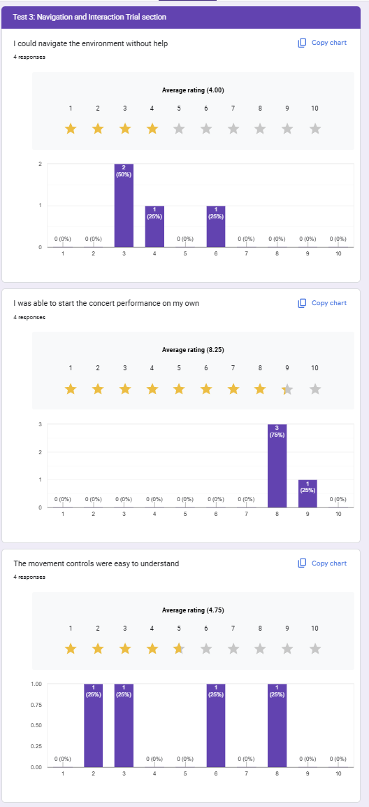

Figure 4.1

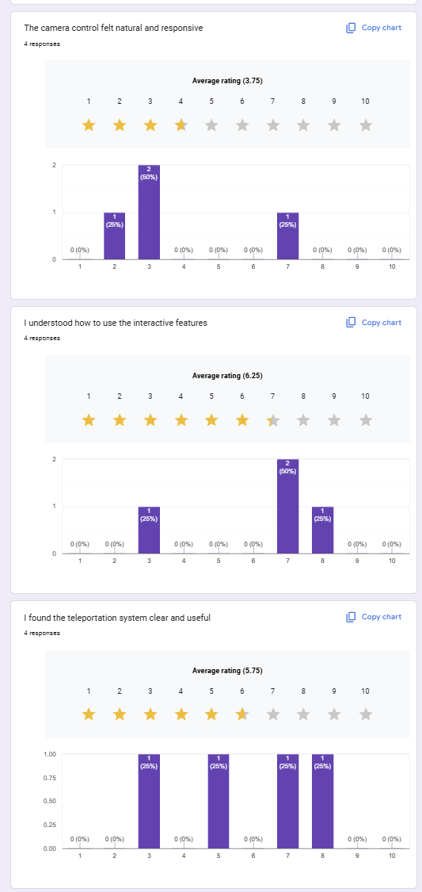

Figure 4.2

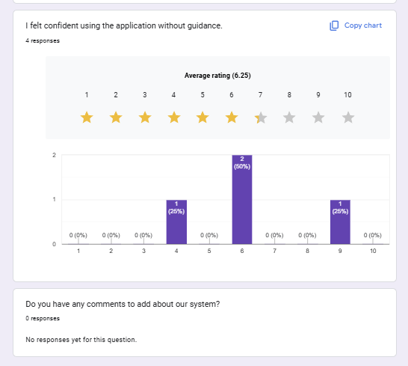

Figure 4.3

Tables



Table 1



Table 2



Table 3